**CODING:**

#include <iostream>

using namespace std;

int main() {

int n, f;

cout << "Enter number of pages: ";

cin >> n;

int pages[n];

cout << "Enter page reference string: ";

for (int i = 0; i < n; i++){

cin >> pages[i];

}

cout << "Enter number of frames: ";

cin >> f;

int frames[f], front = 0, pageFaults = 0, pageHits = 0;

for (int i = 0; i < f; i++){

frames[i] = -1;

}

for (int i = 0; i < n; i++) {

bool found = false;

for (int j = 0; j < f; j++){

if (frames[j] == pages[i]) {

found = true; break;

}

}

if (!found) {

frames[front] = pages[i];

front = (front + 1) % f;

pageFaults++;

} else {

pageHits++;

}

cout << "After page " << pages[i] << " -> [ ";

for (int j = 0; j < f; j++) {

if (frames[j] == -1) cout << "- ";

else cout << frames[j] << " ";

}

cout << "]\n";

}

cout << "\nTotal Page Faults (FIFO): " << pageFaults;

cout << "\nTotal Page Hits (FIFO): " << pageHits;

cout << "\nMiss Ratio: " << (float)pageFaults / n;

cout << "\nHit Ratio: " << (float)pageHits / n;

}

**OUTPUT:**

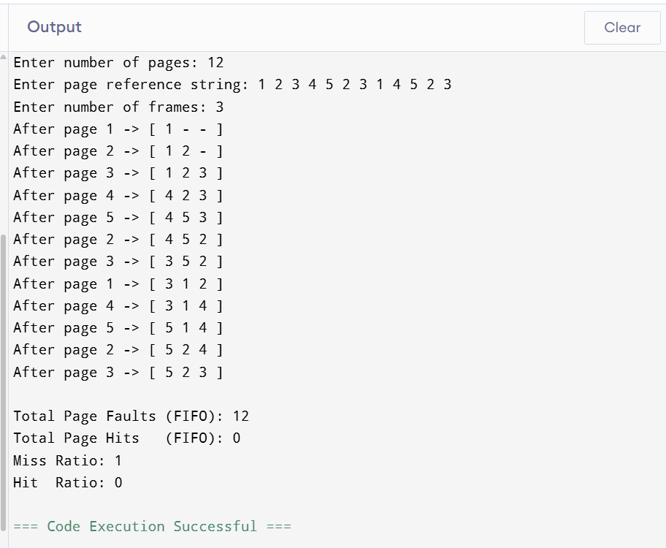

**CODING:**

#include <iostream>

using namespace std;

int main() {

int n, f;

cout << "Enter number of pages: ";

cin >> n;

int pages[n];

cout << "Enter page reference string: ";

for (int i = 0; i < n; i++){

cin >> pages[i];

}

cout << "Enter number of frames: ";

cin >> f;

int frames[f], pageFaults = 0, pageHits = 0;

for (int i = 0; i < f; i++){

frames[i] = -1;

}

for (int i = 0; i < n; i++) {

bool found = false;

for (int j = 0; j < f; j++){

if (frames[j] == pages[i]) {

found = true; break;

}

}

if (!found) {

if (i < f) {

frames[i] = pages[i];

}else {

int least = i, pos = -1;

for (int j = 0; j < f; j++) {

int k;

for (k = i - 1; k >= 0; k--){

if (frames[j] == pages[k]){

break;

}

}

if (k < least) { least = k; pos = j; }

}

frames[pos] = pages[i];

}

pageFaults++;

} else {

pageHits++;

}

cout << "After page " << pages[i] << " -> [ ";

for (int j = 0; j < f; j++) {

if (frames[j] == -1) cout << "- ";

else cout << frames[j] << " ";

}

cout << "]\n";

}

cout << "\nTotal Page Faults (LRU): " << pageFaults;

cout << "\nTotal Page Hits (LRU): " << pageHits;

cout << "\nMiss Ratio: " << (float)pageFaults / n;

cout << "\nHit Ratio: " << (float)pageHits / n;

}

**OUTPUT:**

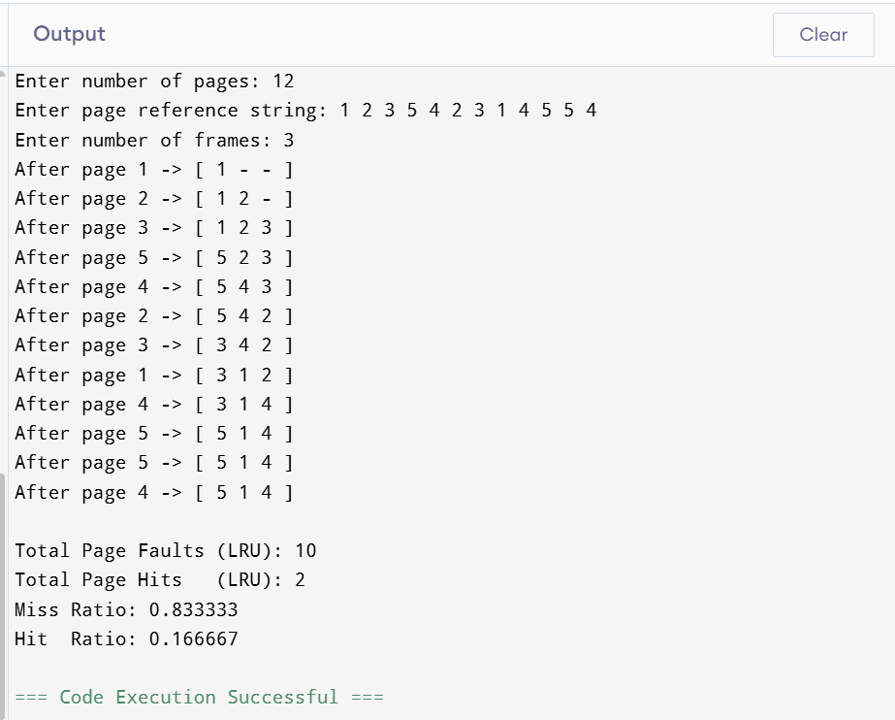

**CODING:**  
#include <iostream>

using namespace std;

int main() {

int n, f;

cout << "Enter number of pages: ";

cin >> n;

int pages[n];

cout << "Enter page reference string: ";

for (int i = 0; i < n; i++){

cin >> pages[i];

}

cout << "Enter number of frames: ";

cin >> f;

int frames[f], pageFaults = 0, pageHits = 0;

for (int i = 0; i < f; i++){

frames[i] = -1;

}

for (int i = 0; i < n; i++) {

bool found = false;

for (int j = 0; j < f; j++){

if (frames[j] == pages[i]){

found = true;

}

}

if (!found) {

if (i < f) {

frames[i] = pages[i];

}else {

int farthest = i, pos = -1;

for (int j = 0; j < f; j++) {

int k;

for (k = i + 1; k < n; k++){

if (frames[j] == pages[k]){

break;

}

}

if (k > farthest) {

farthest = k; pos = j;

}

}

if (pos == -1) pos = 0;

frames[pos] = pages[i];

}

pageFaults++;

} else {

pageHits++;

}

cout << "After page " << pages[i] << " -> [ ";

for (int j = 0; j < f; j++) {

if (frames[j] == -1) cout << "- ";

else cout << frames[j] << " ";

}

cout << "]\n";

}

cout << "\nTotal Page Faults (Optimal): " << pageFaults;

cout << "\nTotal Page Hits (Optimal): " << pageHits;

cout << "\nMiss Ratio: " << (float)pageFaults / n;

cout << "\nHit Ratio: " << (float)pageHits / n;

}

**OUTPUT:**

